# **Unit 24: Offensive Report:**

# **Red Team: Summary of Operations**

## **Table of Contents**

* Exposed Services
* Critical Vulnerabilities
* Exploitation**Exposed Services**

Nmap scan results for each machine reveal the below services and OS details: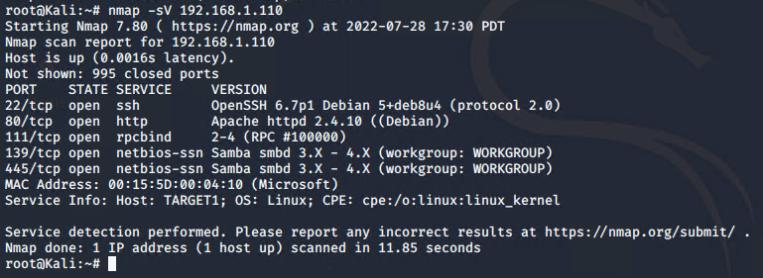

This scan identifies the services below as potential points of entry:

* Target 1
  + ssh
  + http
  + rpc services
  + netbios-ssn

The following vulnerabilities were identified on each target:

* Target 1
  + Ssh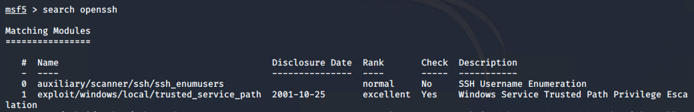
    - CVE-2002-1645 score 10.0
    - Attackers execute arbitrary code via long URL
  + Http
    - CVE-2022-31813 score 7.5
    - This may be used to bypass IP based authentication on the origin server/application.
  + SMB vulnerabilities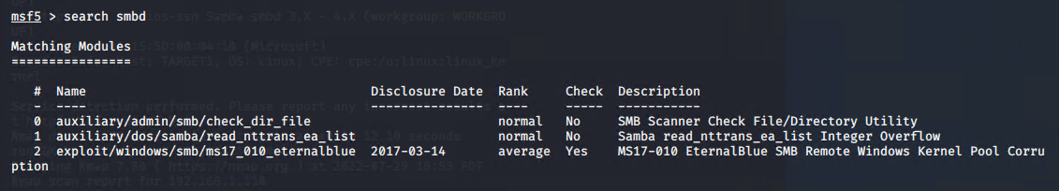
    - CVE-2020-1472 score 10.0 Elevation of privilege
    - CWE-287: Improper Authentication
    - CVE-2021-44142 Complete CIA impact
  + rpcbind only has normal vulnerabilites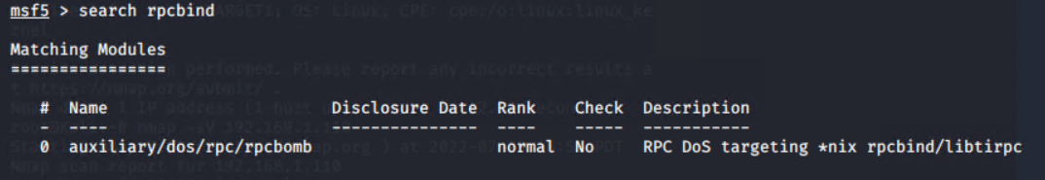

### **Exploitation**

The Red Team was able to penetrate Target 1 and retrieve the following confidential data:

* Target 1
  + flag1.txt: *flag1{b9bbcb33e11b80be759c4e844862482d}*
    - **Exploit Used**
      * *Guessing*
      * *Entering the name michael for the password*
      * *grep -RE flag1 html*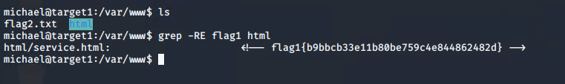
  + flag2.txt: *flag2{fc3fd58dcdad9ab23faca6e9a36e581c}*
    - **Exploit Used**
      * *Guessing the password “Michael”*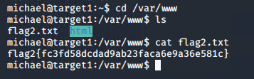
      * *Obtained hashes and used john the ripper to crack them for obtaining the password for steven*
      * *With that password I was able to find the 3rd and 4th flag*